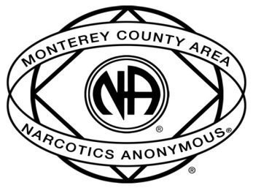

Announcing Hospital & Institutions
Santa Cruz Area Inmate Correspondence Program
Monterey County Inmate Correspondence Program

BEHIND the WALLS (BTW)
- Must have 1 year clean and have worked the 12 Steps of Narcotics Anonymous.
- Must be willing to make a commitment to corresponding by mail.
- Must be willing to stay focused on recovery.
- Must be willing to follow the rules of the facility.
- Men write to men and women write to women.
- You may NOT correspond with an inmate in a facility where you take meetings.
- Must be willing to attend H&I Meetings to meet with BTW Coordinator as requested.
Name Clean Date E-mail Phone #

Take this form to your group and return it to the H&I Area Chair at ASC. Santa Cruz Area BTW will match you with an inmate and Monterey County Area BTW will provide you with the name and address, so you can start corresponding. Please return this form promptly so we can get the program started. If you have questions, please call (831) 758-1630 Ext 815

